Project Design Phase-II
Data Flow Diagram & User Stories

Date | 28 September 2026
Team ID | SWTID-2026-9713
Project Name | AI FitTrack API
Maximum Marks | 4 Marks.

Data Flow Diagrams:
A Data Flow Diagram (DFD) is a traditional visual representation of the information flows within a system. A neat and clear DFD can depict the right amount of the system requirement graphically. It shows how data enters and leaves the system, what changes the information, and where data is stored.

AI FitTrack API – DFD Level 0
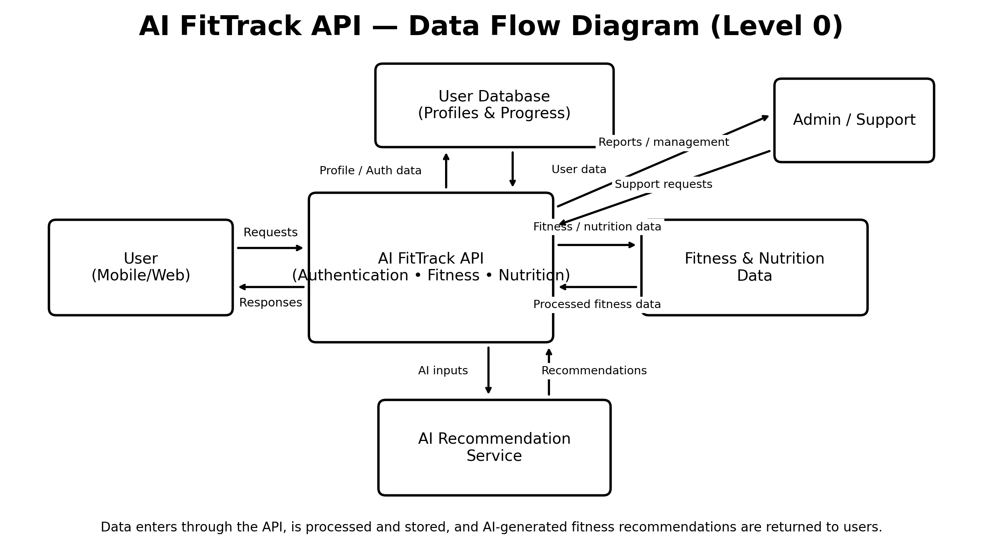

User Stories
Use the below template to list all the user stories for the product.
User Type | Functional Requirement (Epic) | User Story Number | User Story / Task | Acceptance criteria | Priority | Release
Customer (Mobile user) | Registration | USN-1 | As a user, I can create an account using my email and password. | Account is created and dashboard is accessible. | High | Sprint-1
Customer (Mobile user) | Login | USN-2 | As a user, I can log in securely using my registered credentials. | Valid credentials open the user dashboard. | High | Sprint-1
Customer (Mobile user) | Profile | USN-3 | As a user, I can enter and update my age, height, weight and fitness details. | Profile data is saved and displayed correctly. | High | Sprint-1
Customer (Mobile user) | Fitness Goals | USN-4 | As a user, I can select fitness goals such as weight loss, strength or fitness. | Selected goal is saved to the profile. | High | Sprint-1
Customer (Mobile user) | Workout Plan | USN-5 | As a user, I can receive a workout plan based on my fitness profile and goal. | A suitable workout plan is generated and displayed. | High | Sprint-2
Customer (Mobile user) | AI Recommendation | USN-6 | As a user, I can receive AI-based fitness recommendations. | Recommendations are returned through the API. | High | Sprint-2
Customer (Mobile user) | Progress Tracking | USN-7 | As a user, I can record workouts and track my fitness progress. | Workout records and progress are stored and displayed. | High | Sprint-2
Customer (Mobile user) | Nutrition | USN-8 | As a user, I can receive nutrition suggestions related to my fitness goal. | Nutrition suggestions are displayed for the selected goal. | Medium | Sprint-2
Customer (Web user) | Dashboard | USN-9 | As a web user, I can view my profile, plans and progress from a dashboard. | Dashboard shows current user data and progress. | Medium | Sprint-2
Customer Care Executive | Support | USN-10 | As a customer care executive, I can view user details and respond to support requests. | Authorized staff can access and update support records. | Medium | Sprint-3
Administrator | User Management | USN-11 | As an administrator, I can manage registered users and their access. | Admin can view, update or deactivate user accounts. | High | Sprint-3
Administrator | System Management | USN-12 | As an administrator, I can manage workout, nutrition and AI recommendation data. | Authorized changes are saved and reflected in the API. | Medium | Sprint-3

